WRITING AND SIMPLIFYING RATIO
Pearson Edexcel - Thursday 6 June 2019 - Paper 2 (Calculator) Foundation Tier

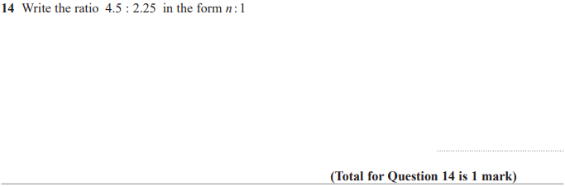

Pearson Edexcel - Tuesday 6 November 2018 - Paper 1 (Non-Calculator) Foundation Tier

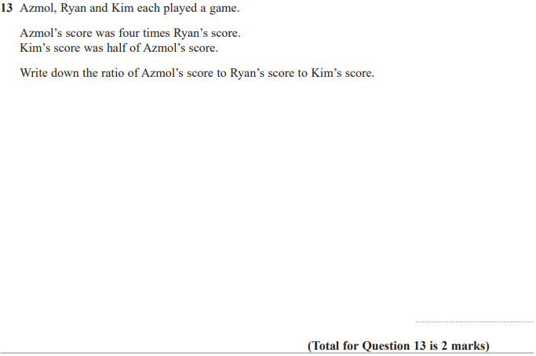

Pearson Edexcel - Monday 12 November 2018 - Paper 3 (Calculator) Foundation Tier

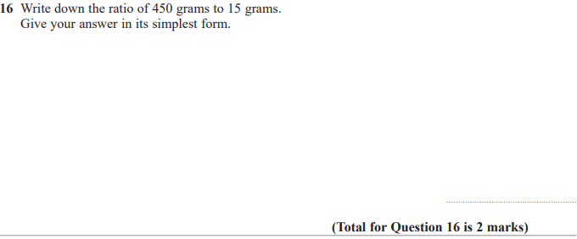

Pearson Edexcel - Thursday 24 May 2018 - Paper 1 (Non-Calculator) Foundation Tier

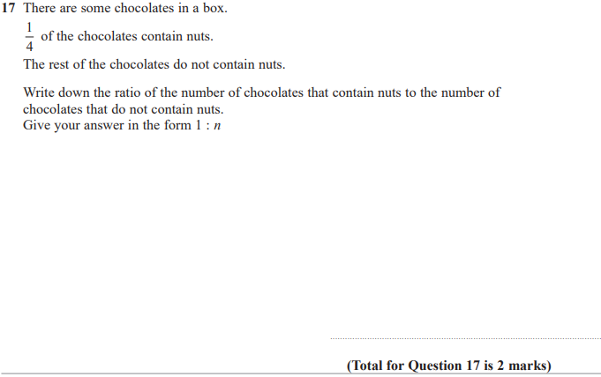

Pearson Edexcel - Monday 6 November 2017 - Paper 2 (Calculator) Foundation Tier

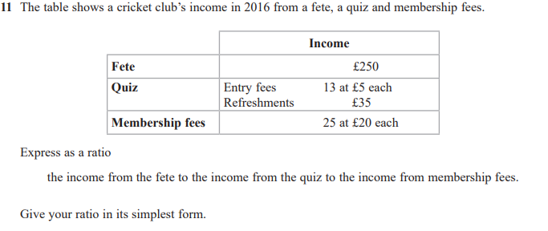

Pearson Edexcel – Specimen 2 - Paper 3 (Calculator) Foundation Tier

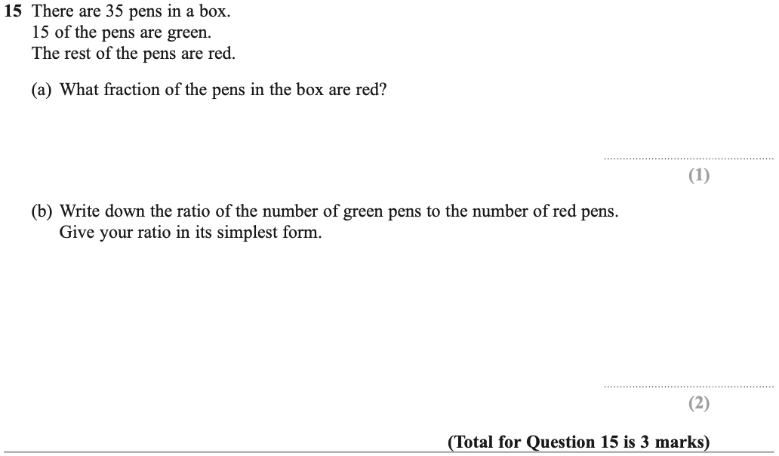

Pearson Edexcel – Specimen 1 - Paper 1 (Non-Calculator) Foundation Tier

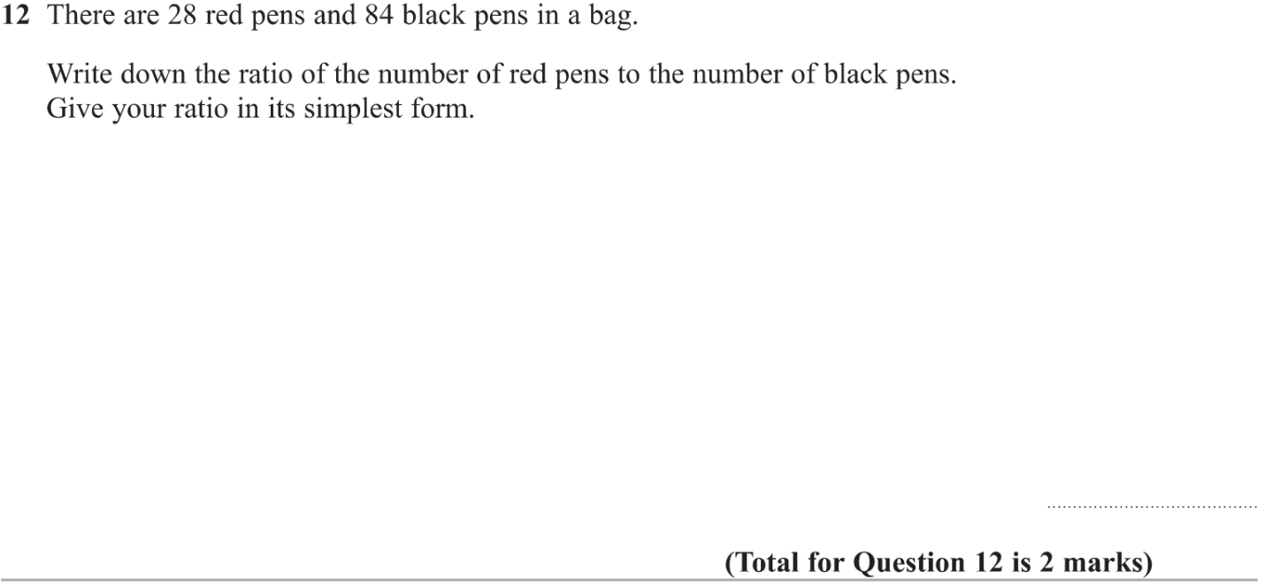

Pearson Edexcel – Specimen 1 - Paper 3 (Calculator) Foundation Tier

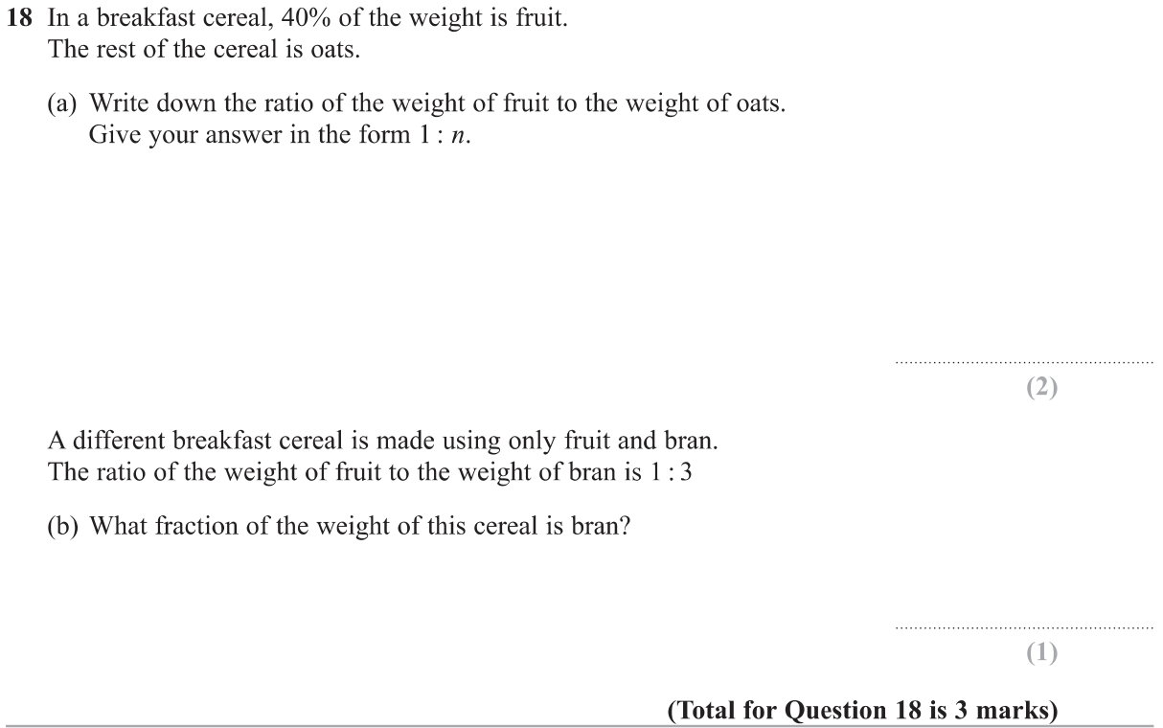

OCR Thursday 05 November 2020- Morning (Non-Calculator) Foundation Tier
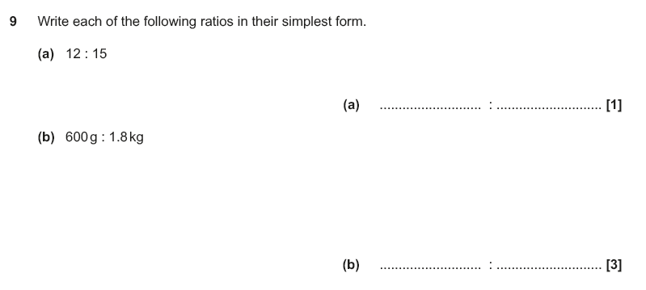

OCR Thursday 07 November 2019- Morning (Non-Calculator) Foundation Tier
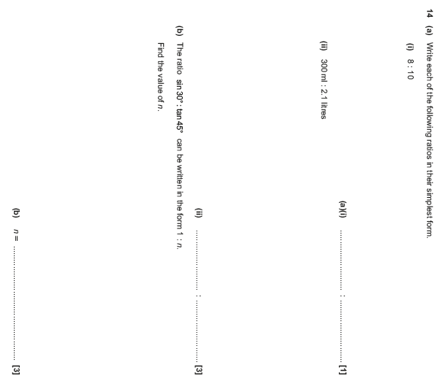

OCR Tuesday 11 June 2019 – Morning (Calculator) Foundation Tier
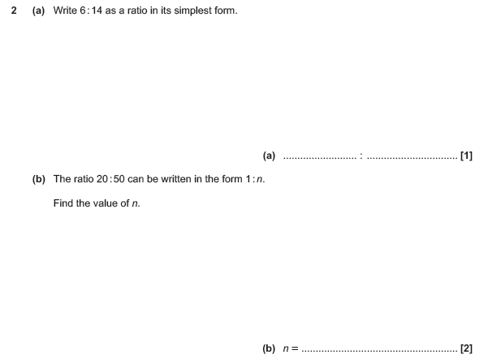

OCR Tuesday 6 November 2018 – Morning (Calculator) Foundation Tier
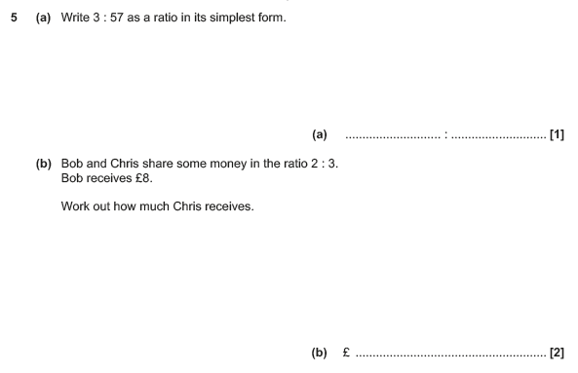

OCR Tuesday 12 June 2018– Morning (Calculator) Foundation Tier
